Coronavirus disease 2019 (COVID-19)
Situation Report – 29

Data as reported by 18 February 2020*

HIGHLIGHTS

- No new countries reported cases of COVID-19 in the past 24 hours.

- WHO Operations Support and Logistics (OSL) continues to gather and assess the needs of Member States for critical items such as Personal Protective Equipment (PPE). On 14 February, OSL started the dispatch of laboratory COVID-19 testing kits for 56 countries. As of 17 February, 37 shipments have been dispatched to 34 countries and three regional offices.

- Health care workers are on the front line of the response to the COVID-19 outbreak. WHO has developed guidance on the Rights, Roles and Responsibilities Of Health Workers, Including Key Considerations For Occupational Safety And Health.

SITUATION IN NUMBERS
total and new cases in last 24 hours

Globally
73 332 confirmed (1901 new)

China
72 528 confirmed (1891 new)
1870 deaths (98 new) †

Outside of China
804 confirmed (10 new)
25 countries
3 deaths

WHO RISK ASSESSMENT

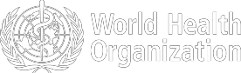
China | Very High
Regional Level | High
Global Level | High

Figure 1. Countries, territories or areas with reported confirmed cases of COVID-19, 18 February 2020

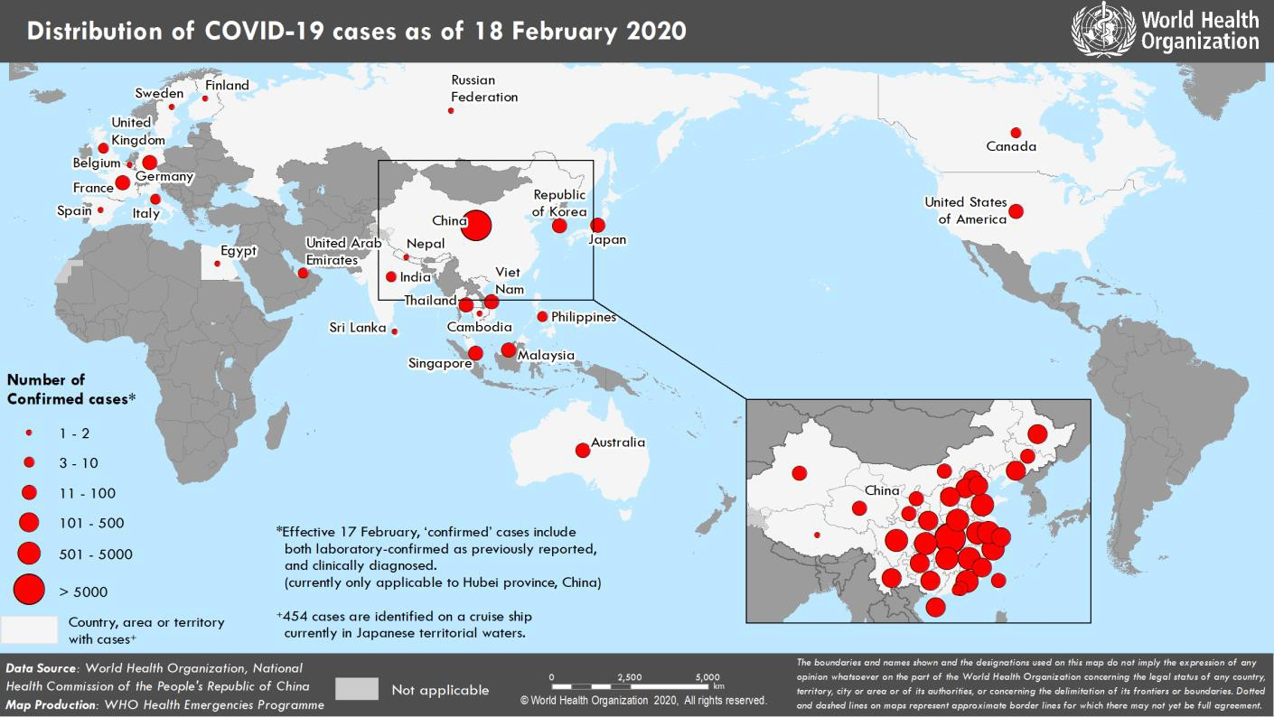
*The situation report includes information provided by national authorities as of 10 AM Central European Time
†As reported by China

TECHNICAL FOCUS: Operations Support and Logistics

WHO Operations Support and Logistics (OSL) continues to gather and assess the needs of Member States for critical items such as personal protective equipment (PPE). The country- level perspective is aggregated to obtain a global view on the overall demand for PPE necessary for frontline healthcare workers. Due to the growing demand and consumption of PPE, OSL is collaborating with WHO disease specialists to develop and disseminate a guiding document on the rational use of PPE.

In the meantime, OSL continues to accelerate the work of the Pandemic Supply Chain Network (PSCN), which includes manufacturers of medical products and medicines, medical distributors, and logistics providers.

Since the activation of the PSCN, the market for PPE continues to experience unprecedented demand. Government export restrictions have continued to limit the supply of products across borders. The PSCN is continuously exploring options with its stakeholders to alleviate the demand and increase the supply to ensure access to PPE for those countries most vulnerable and most in need. This includes working with WHO technical specialists to advocate via the PSCN on the proper use of PPE, understanding the potential for manufacturing expansion outside China (a major source of crucial commodities), and working with stakeholders to support the prioritization of PPE for frontline healthcare workers. The PSCN will also prepare for any bottlenecks in the market for other supplies as listed in the Disease Commodity Package.

On 14 February, OSL started the dispatch of COVID-19 laboratory testing kits for 56 countries. As of 17 February, 37 shipments have been dispatched to 34 countries and three regional offices.

The WHO global supply team had already dispatched 28 PPE shipments totalling more than 12 000 kg to priority countries in the Western Pacific, South-East Asia and African regions. Another 24 shipments are being processed this week to cover other priority countries.

With the technical support of the WHO Infection Prevention & Control (IPC) team, OSL continues to update the Disease Commodity Package (DCP) for COVID-19. This document provides the technical guidance and specifications on the critical supplies necessary to fight COVID-19. Responding organizations and countries preparing and responding to COVID-19 are able to use the DCP to secure the correct supplies in the areas of surveillance, prevention and control, and case management.
SURVEILLANCE

Table 1. Confirmed and suspected cases of COVID-19 acute respiratory disease reported by provinces, regions and cities in China, 18 February 2020

Province/ Region/ | Population (10,000s) | Confirmed | Daily Suspected |  | Cumulative  Confirmed Deaths
City | cases* |  | cases | Deaths | cases
Hubei | 5917 | 1807 | 788 | 93 | 59989 |  | 1789
Guangdong | 11346 | 6 | 0 | 0 | 1328 |  | 4
Henan | 9605 | 11 | 102 | 3 | 1257 |  | 19
Zhejiang | 5737 | 1 | 15 | 0 | 1172 |  | 0
Hunan | 6899 | 1 | 15 | 1 | 1007 |  | 4
Anhui | 6324 | 9 | 7 | 0 | 982 |  | 6
Jiangxi | 4648 | 3 | 0 | 0 | 933 |  | 1
Jiangsu | 8051 | 3 | 4 | 0 | 629 |  | 0
Chongqing | 3102 | 2 | 50 | 0 | 553 |  | 5
Shandong | 10047 | 2 | 17 | 0 | 543 |  | 2
Sichuan | 8341 | 13 | 28 | 0 | 508 |  | 3
Heilongjiang | 3773 | 7 | 32 | 0 | 464 |  | 11
Beijing | 2154 | 6 | 49 | 0 | 387 |  | 4
Shanghai | 2424 | 2 | 65 | 0 | 333 |  | 1
Hebei | 7556 | 1 | 1 | 1 | 302 |  | 4
Fujian | 3941 | 2 | 2 | 0 | 292 |  | 0
Guangxi | 4926 | 4 | 21 | 0 | 242 |  | 2
Shaanxi | 3864 | 0 | 22 | 0 | 240 |  | 0
Yunnan | 4830 | 1 | 18 | 0 | 172 |  | 0
Hainan | 934 | 1 | 22 | 0 | 163 |  | 4
Guizhou | 3600 | 0 | 2 | 0 | 146 |  | 1
Shanxi | 3718 | 1 | 6 | 0 | 130 |  | 0
Tianjin | 1560 | 1 | 83 | 0 | 125 |  | 3
Liaoning | 4359 | 0 | 64 | 0 | 121 |  | 1
Gansu | 2637 | 0 | 0 | 0 | 91 |  | 2
Jilin | 2704 | 0 | 14 | 0 | 89 |  | 1
Xinjiang | 2487 | 1 | 1 | 0 | 76 |  | 1
Inner Mongolia | 2534 | 1 | 0 | 0 | 73 |  | 0
Ningxia | 688 | 0 | 4 | 0 | 70 |  | 0
Hong Kong SAR | 745 | 3 | 0 | 0 | 60 |  | 1
Taipei and environs | 2359 | 2 | 0 | 0 | 22 |  | 1
Qinghai | 603 | 0 | 0 | 0 | 18 |  | 0
Macao SAR | 66 | 0 | 0 | 0 | 10 |  | 0
Xizang | 344 | 0 | 0 | 0 | 1 |  | 0
Total | 142823 | 1891 | 1432 | 98 | 72528 |  | 1870
*‘Confirmed’ cases include both laboratory confirmed and clinically diagnosed cases (currently only applicable to Hubei province, China)
Table 2. Countries, territories or areas outside China with reported laboratory-confirmed COVID-19 cases and deaths. Data as of 18 February 2020

Confirmed
WHO Region | Country/Territory/Area | *  cases (new) | Total cases with travel history to China (new) | Total cases with possible or confirmed transmission outside of China† (new) | Total cases with site of transmission under investigation (new) | Total deaths (new)
Western Pacific Region | Singapore | 77 (2) | 23 (1) | 53 (1) | 1 (0) | 0 (0)
Western Pacific Region | Japan | 65 (6) | 26 (0) | 39 (6) | 0 (0) | 1 (0)
Western Pacific Region | Republic of Korea | 31 (1) | 13 (0) | 15‡ (1) | 3 (0) | 0 (0)
Western Pacific Region | Malaysia | 22 (0) | 17 (0) | 4§ (0) | 1 (0) | 0 (0)
Western Pacific Region | Viet Nam | 16 (0) | 8 (0) | 8 (0) | 0 (0) | 0 (0)
Western Pacific Region | Australia | 15 (0) | 12 (0) | 3 (0) | 0 (0) | 0 (0)
Western Pacific Region | Philippines | 3 (0) | 3 (0) | 0 (0) | 0 (0) | 1 (0)
Western Pacific Region | Cambodia | 1 (0) | 1 (0) | 0 (0) | 0 (0) | 0 (0)
South-East Asia Region | Thailand | 35 (0) | 23 (0) | 7 (0) | 5 (0) | 0 (0)
South-East Asia Region | India | 3 (0) | 3 (0) | 0 (0) | 0 (0) | 0 (0)
South-East Asia Region | Nepal | 1 (0) | 1 (0) | 0 (0) | 0 (0) | 0 (0)
South-East Asia Region | Sri Lanka | 1 (0) | 1 (0) | 0 (0) | 0 (0) | 0 (0)
Region of the Americas | United States of America | 15 (0) | 13 (0) | 2 (0) | 0 (0) | 0 (0)
Region of the Americas | Canada | 8 (1) | 6 (0) | 0 (0) | 2 (1) | 0 (0)
European Region | Germany | 16 (0) | 2 (0) | 14 (0) | 0 (0) | 0 (0)
European Region | France | 12 (0) | 5 (0) | 7 (0) | 0 (0) | 1 (0)
European Region | The United Kingdom | 9 (0) | 2 (0) | 7** (0) | 0 (0) | 0 (0)
European Region | Italy | 3 (0) | 3 (0) | 0 (0) | 0 (0) | 0 (0)
European Region | Russian Federation | 2 (0) | 2 (0) | 0 (0) | 0 (0) | 0 (0)
European Region | Spain | 2 (0) | 0 (0) | 2†† (0) | 0 (0) | 0 (0)
European Region | Belgium | 1 (0) | 1 (0) | 0 (0) | 0 (0) | 0 (0)
European Region | Finland | 1 (0) | 1 (0) | 0 (0) | 0 (0) | 0 (0)
European Region | Sweden | 1 (0) | 1 (0) | 0 (0) | 0 (0) | 0 (0)
Eastern Mediterranean Region | United Arab Emirates | 9 (0) | 6 (0) | 2 (0) | 1 (0) | 0 (0)
Eastern Mediterranean Region | Egypt | 1 (0) | 0 (0) | 1 (0) | 0 (0) | 0 (0)
Other | International conveyance (Japan) | 454‡‡ (0) | 0 (0) | 0 (0) | 454 (0) | 0 (0)

*Case classifications are based on WHO case definitions for COVID-19.
†Location of transmission is classified based on WHO analysis of available official data and may be subject to reclassification as additional data become available.
‡The exposure for 3 cases occurred outside of Republic of Korea.
§The exposure for 1 case occurred outside of Malaysia. One patient also had travel history to China, but exposure likely occurred after return to Malaysia.
**The exposure for 6 cases occurred outside of the United Kingdom.
††The exposure for 2 cases occurred outside of Spain.
‡‡Cases identified on a cruise ship currently in Japanese territorial waters.
Figure 2. Epidemic curve of COVID-19 cases (n=215) identified outside of China, by date of onset of symptoms and travel history, 18 February 2020

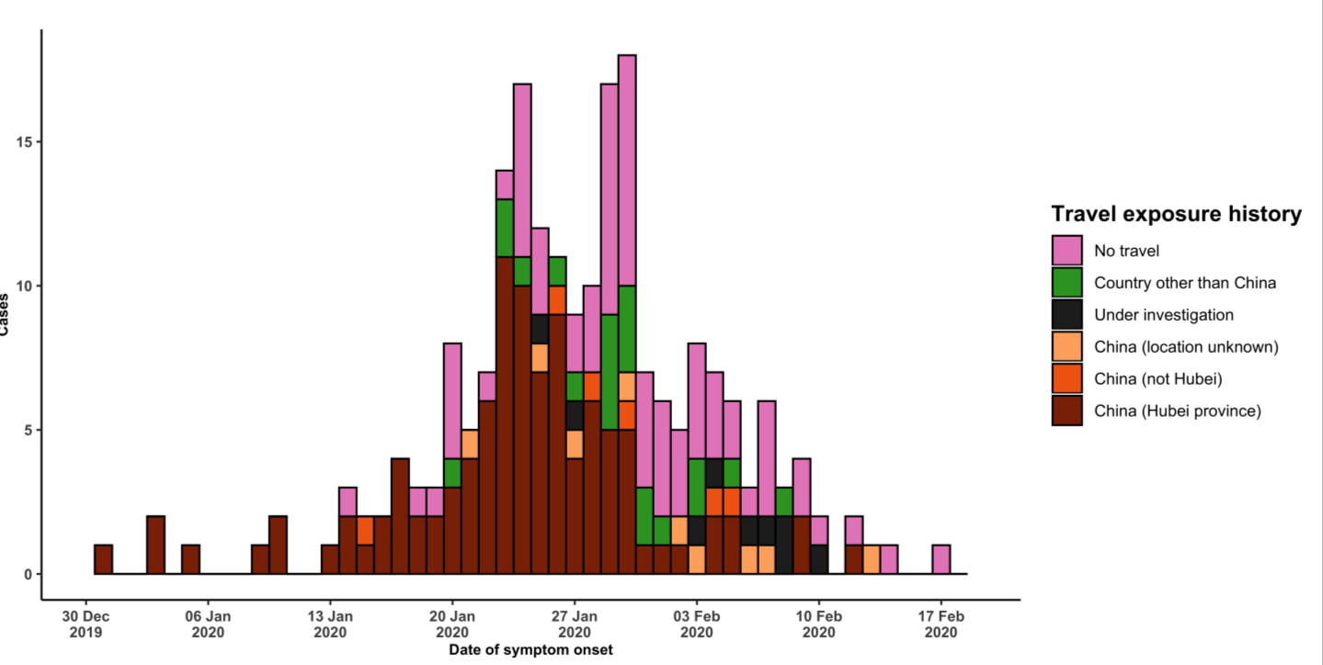

Note for figure 2: Of the 804 cases reported outside China, 27 were detected while apparently asymptomatic. For the remaining 777 cases, information on date of onset is available only for the 215 cases presented in the epidemiologic curve.

Figure 3. Epidemic curve of COVID-19 cases (n=804) identified outside of China, by date of reporting and travel history, 18 February 2020
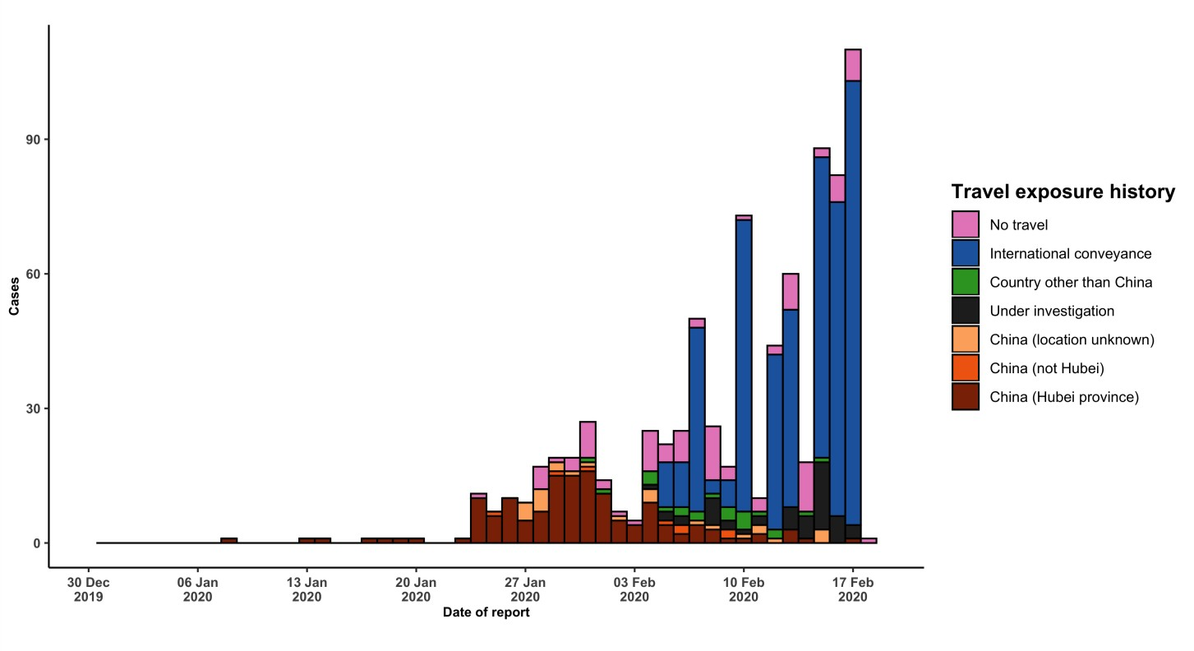

STRATEGIC OBJECTIVES

WHO’s strategic objectives for this response are to:

- Limit human-to-human transmission including reducing secondary infections among close contacts and health care workers, preventing transmission amplification events, and preventing further international spread from China*;
- Identify, isolate and care for patients early, including providing optimized care for infected patients;
- Identify and reduce transmission from the animal source;
- Address crucial unknowns regarding clinical severity, extent of transmission and infection, treatment options, and accelerate the development of diagnostics, therapeutics and vaccines;
- Communicate critical risk and event information to all communities and counter misinformation;
- Minimize social and economic impact through multisectoral partnerships.

*This can be achieved through a combination of public health measures, such as rapid identification, diagnosis and management of the cases, identification and follow up of the contacts, infection prevention and control in health care settings, implementation of health measures for travelers, awareness-raising in the population and risk communication.

PREPAREDNESS AND RESPONSE

- To view all technical guidance documents regarding COVID-19, please go to this webpage.
- WHO is working closely with International Air Transport Association (IATA) and have jointly developed a guidance document to provide advice to cabin crew and airport workers, based on country queries. The guidance can be found on the IATA webpage.
- WHO has developed a protocol for the investigation of early cases (the “First Few X (FFX) Cases and contact investigation protocol for 2019-novel coronavirus (2019-nCoV) infection”). The protocol is designed to gain an early understanding of the key clinical, epidemiological and virological characteristics of the first cases of COVID- 19 infection detected in any individual country, to inform the development and updating of public health guidance to manage cases and reduce potential spread and impact of infection.
- WHO has been in regular and direct contact with Member States where cases have been reported. WHO is also informing other countries about the situation and providing support as requested.
- WHO has developed interim guidance for laboratory diagnosis, advice on the use of masks during home care and in health care settings in the context of the novel coronavirus (2019-nCoV) outbreak, clinical management, infection prevention and control in health care settings, home care for patients with suspected novel coronavirus, risk communication and community engagement and Global Surveillance for human infection with novel coronavirus (2019-nCoV).
- WHO has prepared disease commodity package that includes an essential list of biomedical equipment, medicines and supplies necessary to care for patients with 2019-nCoV.
- WHO has provided recommendations to reduce risk of transmission from animals to humans.
- WHO has published an updated advice for international traffic in relation to the outbreak of the novel coronavirus 2019-nCoV.
- WHO has activated of R&D blueprint to accelerate diagnostics, vaccines, and therapeutics.
- WHO has developed an online course to provide general introduction to emerging respiratory viruses, including novel coronaviruses.
- WHO is providing guidance on early investigations, which are critical to carry out early in an outbreak of a new virus. The data collected from the protocols can be used to refine recommendations for surveillance and case definitions, to characterize the key epidemiological transmission features of COVID-19, help understand spread, severity, spectrum of disease, impact on the community and to inform operational models for implementation of
countermeasures such as case isolation, contact tracing and isolation. Several protocols are available here: https://www.who.int/emergencies/diseases/novel-coronavirus-2019/technical-guidance/early-investigations
- WHO is working with its networks of researchers and other experts to coordinate global work on surveillance, epidemiology, modelling, diagnostics, clinical care and treatment, and other ways to identify, manage the disease and limit onward transmission. WHO has issued interim guidance for countries, which are updated regularly.
- WHO is working with global expert networks and partnerships for laboratory, infection prevention and control, clinical management and mathematical modelling.

RECOMMENDATIONS AND ADVICE FOR THE PUBLIC

During previous outbreaks due to other coronavirus (Middle-East Respiratory Syndrome (MERS) and Severe Acute Respiratory Syndrome (SARS), human-to-human transmission occurred through droplets, contact and fomites, suggesting that the transmission mode of the COVID-19 can be similar. The basic principles to reduce the general risk of transmission of acute respiratory infections include the following:

- Avoiding close contact with people suffering from acute respiratory infections.
- Frequent hand-washing, especially after direct contact with ill people or their environment.
- Avoiding unprotected contact with farm or wild animals.
- People with symptoms of acute respiratory infection should practice cough etiquette (maintain distance, cover coughs and sneezes with disposable tissues or clothing, and wash hands).
- Within health care facilities, enhance standard infection prevention and control practices in hospitals, especially in emergency departments.

WHO does not recommend any specific health measures for travellers. In case of symptoms suggestive of respiratory illness either during or after travel, travellers are encouraged to seek medical attention and share their travel history with their health care provider.

